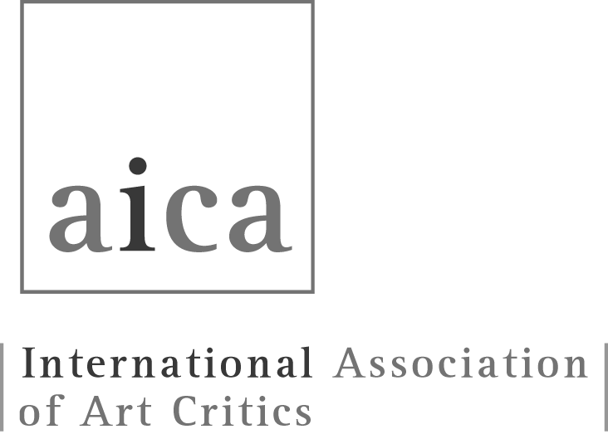 | AICA International  32 rue Yves Toudic, F-75010 Paris  aica.office@gmail.com  www.aicainternational.news

AICA MEMBERSHIP:

BIOGRAPHICAL FORM
Information for National Sections:

National Sections should forward the Biographical Form for each new member to the Secretary General and the AICA International Office, but only after the new membership has been approved by the National Section, in accordance with Article 3.1 of the AICA International Statutes.

Information for applicants

All information in this Biographical Form is confidential and mandatory.

Before completing the Biographical Form, please refer to the guidelines titled “How to Fill in the Biographical Form,” available on the AICA International website or by emailing aica.office@gmail.com.

Please name the file as follows:
Year_Spring or Autumn_EMC_Country_Name_Surname of the candidate.
Save the file as a PDF.

AICA MEMBERSHIP BIOGRAPHICAL FORM
(TO BE COMPLETED BY THE APPLICANT)
Are you applying to join a National Section or the Open Section?
National Section Open Section

If applying to a National Section, please specify the name of the Section:
President of the National Section endorsing this application (or indicate “Open Section” if applicable):
Names of two sponsors, who are on the board (mandatory for applicants to the Open Section, optional for applicants to the National Section):
Sponsor 1:
Sponsor 2:
Date of this application (dd/mm/yyyy):
Applicant’s Surname:
First Name:
Nationality:
Date of Birth (dd/mm/yyyy):
Place of Birth:

Gender:
Female Male Other

CONTACT INFORMATION
Home Address:
Phone Number(s) (including area code, e.g. +44 for the UK):
Email:
Website (if applicable):

PROFESSIONAL INFORMATION
Institution / Organisation / Publication for which you work:
Professional Address:
Phone Number(s) (including area code, e.g. +44 for the UK):
Email:
Website (if applicable):
Professional Title(s) and Qualification(s):

Do you authorise your name and email address to be published in AICA's online Membership Directory, accessible only to AICA members?
My name and personal email
My name and professional email
I do not authorise

PROFESSIONAL PRACTICE
Please note: You must provide evidence of continuous professional practice over a minimum of the last three years.
Give full information using APA or any other recognised citation style, in reverse chronological order (latest to oldest), including ISSN / ISBN / DOI where relevant.
If including links to online content, ensure that they are functional and publicly accessible – no paywalls or broken links.

MEDIA
Please list your published work, including criticism, reviews, or essays in magazines, journals, and newspapers (print and/or online).

1.
2.
3.
4.
5.
6.
7.
8.
9.
10.

RADIO / BROADCAST / TV / INTERNET

Please list your contributions, including the platform or broadcaster, title of the programme or segment, and duration (start and end times).

1.
2.
3.
4.
5.
6.
7.
8.
9.
10.

PUBLICATIONS
Please list your published essays or texts in books, including: title of your contribution, title of the book or catalogue, editor, publisher, year of publication, page range of your contribution, and ISSN/ISBN or DOI (if available).

1.
2.
3.
4.
5.
6.
7.
8.
9.
10.

TEACHING
Please provide details of your teaching experience, including the name of the institution, level of education, subject area, course title(s), and dates of instruction.

1.
2.
3.
4.
5.
6.
7.
8.
9.
10.

CURATORIAL ACTIVITIES
Please list curatorial projects, including title, date and place. If there is any related publication (books, catalogues, essays, broadcasts, podcasts, etc.), please use APA or any other recognised citation style for the publication details.

1.
2.
3.
4.
5.
6.
7.
8.
9.
10.

CULTURAL ORGANISATIONS
Please list your involvement with cultural institutions, including the name of the organisation, your role or position, and dates of engagement. You may also include any honorary or voluntary activities in this section.

1.
2.
3.
4.
5.
6.
7.
8.
9.
10.

FOR USE BY THE PRESIDENT ENDORSING THIS APPLICATION ONLY
Please submit a short justification explaining why, in your view, this AICA membership application should be accepted. If applicable, also address any gaps, inconsistencies, or nonconformities in the applicant’s information that may not fully comply with AICA International Regulations (Article II – Membership).
This section is not mandatory, but it may assist the Electoral and Membership Committee in their review process.
Type your answer below.

FOR OFFICIAL USE ONLY
AICA Electoral and Membership Committee (EMC)
Membership Application
Accepted
Rejected
Date (dd/mm/yyyy):

Name of EMC Chair or Representative:

Reasons for Rejection (tick all that apply):
Incomplete or missing information in the Biographical Form
Insufficient evidence of continuous professional practice over the last three years in one or more of the four areas defined in Article 2.1 (a–d) of the AICA Statutes
The information provided was untrue or failed to meet the admission criteria
Other (Please specify below)

Action Required:
Return to National Section President
Return to Applicant (Open Section)
Applicant must revise and resubmit the Biographical Form
Comments:

